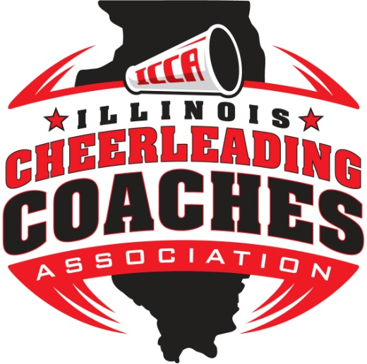

2016 Scholarship Winners

1st Place: Hannah Andrews
2nd Place: Nicole Infantino
3rd Place: Alyssa Dollison
Kaylee Nichols
Nathan O’Connor
Audrey Kosydor
MaKayla Gayler
Chase McQueen
Marissa Wheeler
Jessica Hammel
Kaylen Keele

Oswego East
Addison Trail
O’Fallon
Williamsville
Tremont
Highland
Oakwood
Edwardsville
Highland
Carlyle
Carlyle

